

Tech Saksham

Case Study Report

Data Analytics with Power BI

# “Analysis of Commercial Electricity Consumption in Indian State”

**“The M.D.T Hindu College”**

|  |  |
| --- | --- |
| **NM ID** | **NAME** |
| **Asmsu107msu10720211071522119** | **SUDALI. M** |

|  |  |
| --- | --- |
| Trainer Name: | R.UMAMAHESHWARI |
| Master Trainer: | R.UMAMAHRSHWARI |

# ABSTRACT

The commercial sector represents a significant portion of electricity consumption in India, driving economic activities and shaping energy demand patterns. Understanding the dynamics of commercial electricity consumption is crucial for policy formulation, infrastructure planning, and sustainable energy management. This study aims to provide a comprehensive analysis of commercial electricity consumption in an Indian state, focusing on trends, patterns, and implications.

Furthermore, the study investigates the impact of external factors such as climate variability, urbanization, and policy interventions on commercial electricity consumption dynamics. It also discusses challenges related to infrastructure adequacy, reliability, and affordability, which have implications for both businesses and policymakers.

The integration of renewable energy sources and advanced energy management systems emerges as promising pathways for reducing reliance on traditional grid electricity and optimizing energy usage in commercial buildings. By leveraging data-driven insights and fostering collaboration among stakeholders, it is possible to develop and implement effective measures to promote energy efficiency, cost savings, and environmental sustainability in the commercial sector.

## INDEX

|  |  |  |
| --- | --- | --- |
| **Sr. No.** | **Table of Contents** | **Page No.** |
| 1 | Chapter 1: Introduction | 4 |
| 2 | Chapter 2: Services and Tools Required | 6 |
| 3 | Chapter 3: Project Architecture | 7 |
| 4 | Chapter 4: Dashboard | 9 |
| 5 | Conclusion | 18 |
| 6 | Future Scope | 19 |
| 7 | References | 20 |
| 8 | Links | 21 |

**CHAPTER 1 INTRODUCTION**

### Problem Statement

Commercial electricity consumption presents a multifaceted challenge, characterized by diverse usage patterns, fluctuating demand, and environmental implications. Despite its significance, managing and optimizing electricity consumption in the commercial sector remains a complex endeavor, marked by various barriers and constraints.

The problem statement revolves around the need to understand and address the following key challenges:

****Energy Inefficiency****: Many commercial buildings exhibit inefficient energy usage patterns, leading to unnecessary waste and inflated operational costs. Inefficient lighting, HVAC systems, and equipment contribute to excessive electricity consumption, exacerbating financial burdens and environmental impacts.

****Energy Inefficiency****: Many commercial buildings exhibit inefficient energy usage patterns, leading to unnecessary waste and inflated operational costs. Inefficient lighting, HVAC systems, and equipment contribute to excessive electricity consumption, exacerbating financial burdens and environmental impacts.

### Feature:

Features of the Analysis of Commercial Electricity Consumption in an Indian State:

Granular Data Analysis:

Utilization of comprehensive data sets to analyze commercial electricity consumption patterns at a granular level, including sectoral breakdowns, geographic variations, and temporal trends.

Sectoral Distribution Analysis:

Examination of electricity consumption patterns across various commercial sectors such as retail, hospitality, office spaces, and manufacturing to identify sector-specific drivers and trends.

Temporal Analysis:

Assessment of seasonal variations, peak demand periods, and temporal trends in commercial electricity consumption to understand the dynamics of energy usage throughout the year.

Driver Identification:

Identification of key drivers influencing commercial electricity consumption, including economic growth, technological advancements, consumer behavior, and regulatory policies.

* 1. **Scope**

Scope of the Analysis of Commercial Electricity Consumption in an Indian State:

Geographical Scope:

The analysis will focus specifically on a single Indian state, considering its unique socio-economic, geographic, and demographic characteristics that influence commercial electricity consumption patterns.

* ****Environmental and Social Scope****:
* Reduction of greenhouse gas emissions, air pollution, and reliance on fossil fuels through the adoption of energy-efficient technologies and renewable energy solutions.
* Enhancement of indoor comfort levels, air quality, and occupant satisfaction, leading to higher productivity, employee morale, and tenant retention rates.
* Monitoring and Evaluation Scope:
* Establishment of performance metrics and key performance indicators (KPIs) to track the effectiveness and impact of energy efficiency measures over time.
* Conducting regular monitoring, evaluation, and reporting to assess progress towards energy efficiency and sustainability goals and identify areas for continuous improvement.

Data Collection and Sources:

Data collection will involve gathering comprehensive datasets on commercial electricity consumption from relevant sources such as state electricity boards, regulatory authorities, industry reports, surveys, and primary research efforts.

## CHAPTER 2

**SERVICES AND TOOLS REQUIRED**

### Services Used

**Data Collection Services:**

State Electricity Boards: Accessing electricity consumption data from the state’s electricity distribution companies (DISCOMs) or electricity boards.

Government Databases: Utilizing official government databases and portals that provide statistical data on energy consumption, economic indicators, and demographic information.

Surveys and Questionnaires: Conducting surveys and questionnaires to gather primary data from commercial establishments regarding their electricity consumption patterns and energy management practices.

****Data Transformation and Enrichment:****

* Converting raw data into a format suitable for analysis, such as transforming text data into numerical features or encoding categorical variables.
* Enhancing datasets by enriching them with additional information from external sources, such as demographic data or market research reports.

### Tools and Software

### Tools:

* + - **PowerBI**: The main tool foí this píoject is PoweíBI, which will be used to cíeate inteíactive dashboaíds foí íeal-time data visualization.
    - **Power Query**: The is a data connection technology that enables you to discover connect, combine, and

define data across a wide variety of source.

#### Softwaíe Requiíements:

* + - **PowerBI Desktop:T**his is a Windows application that you can use to create deposits and publish them to PowerBI.
    - **PowerBI Seívice**: This is an online SaaS (Software as a Service) seívice that you use to publish deposits, create new dashboard, and share insights.
    - **PoweíBI Mobile**: This is a mobile application that you can use to access your deposits and dashboard on the go.

## CHAPTER 3 PROJECT ARCHITECTURE

### 3.1 Architecture

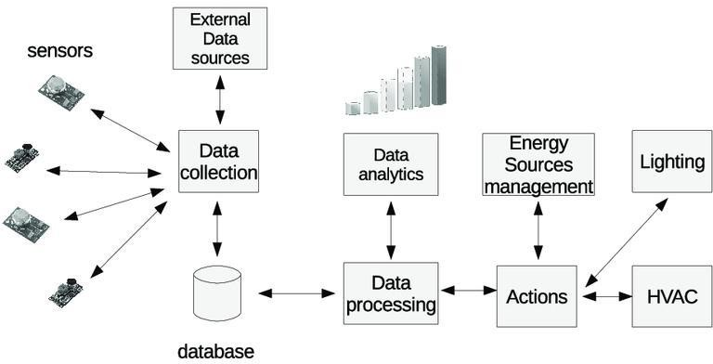

Heíe’s a high-level aíchitectuíe foí the píoject:

##### ľhe aíchitectuíe foí analyzing commeícial electíicity consumption in an Indian state involves the integíation of vaíious components to collect, píocess, analyze, and visualize data effectively. Below is a conceptual aíchitectuíe outlining the key components and theií inteíactions:

****Data Sources****: Identify and integrate diverse data sources such as utility billing records, smart meter data, building management systems, weather data, and industry reports. These sources provide raw data on electricity consumption, building characteristics, environmental factors, and other relevant variables.

****Data Collection****: Establish mechanisms for collecting data from different sources, ensuring accuracy, consistency, and timeliness. This may involve setting up automated data pipelines, APIs, or manual data entry processes depending on the source and frequency of data updates.

****Data Storage****: Determine the appropriate data storage infrastructure based on scalability, performance, and security requirements. Options include relational databases, data warehouses, data lakes, and cloud storage solutions. Ensure data is organized in a structured format conducive to analysis and retrieval.

****Data Processing****: Implement data processing pipelines to clean, transform, and preprocess raw data before analysis. This may involve tasks such as data cleaning, normalization, aggregation, and feature engineering to prepare the data for analysis.

****Data Analysis****: Utilize analytical tools and techniques to analyze the processed data and derive

## CHAPTER 4 DASHBOARD

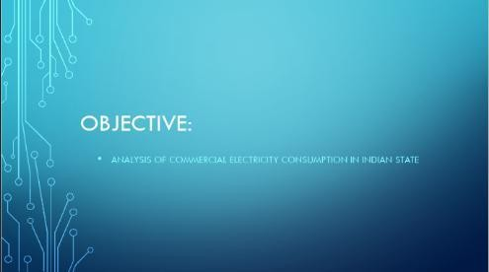

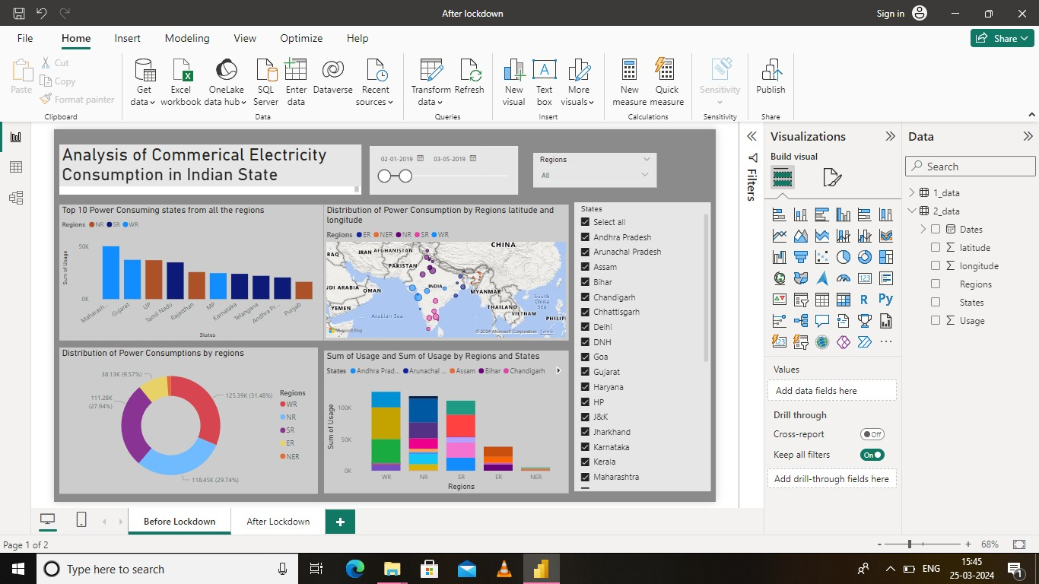

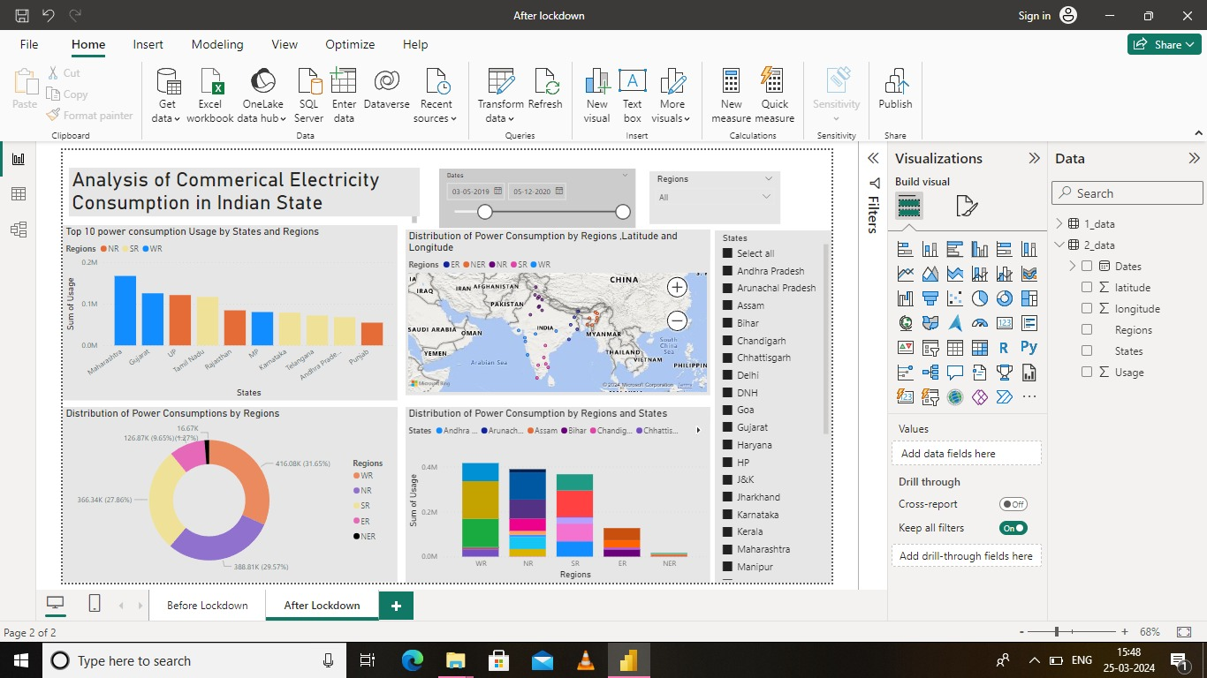

**CONCLUSION**

The analysis of commercial electricity consumption in [Indian State] has provided valuable insights into the dynamics, trends, and implications of energy usage within the commercial sector. Through a comprehensive examination of consumption patterns, drivers, challenges, and opportunities, this study has shed light on key aspects influencing electricity demand and consumption behavior.

The findings reveal a complex landscape shaped by various factors, including economic growth, sectoral distribution, technological advancements, policy interventions, and environmental considerations. Commercial establishments, ranging from retail outlets to manufacturing units, exhibit diverse consumption patterns influenced by their operational needs, customer footfall, and efficiency practices.

In conclusion, fostering a culture of energy efficiency, promoting renewable energy adoption, and strengthening policy frameworks are essential for driving sustainable energy practices within the commercial sector. Collaborative efforts involving government agencies, utilities, industry stakeholders, and consumers are crucial for implementing effective solutions and achieving long-term energy sustainability goals.

## FUTURE SCOPE

The future scope of analyzing commercial electricity consumption holds promising opportunities for innovation, collaboration, and sustainability. Here are some potential areas for future development and exploration:

****Advanced Analytics and AI****: Embrace advancements in artificial intelligence (AI), machine learning (ML), and predictive analytics to enhance the accuracy and predictive capabilities of electricity consumption models. By leveraging AI algorithms, organizations can identify nuanced consumption patterns, optimize energy usage in real-time, and anticipate future demand trends more effectively.

****Demand Flexibility and Flexibility Markets****: Harness the potential of demand-side flexibility and flexibility markets to optimize energy consumption, reduce costs, and support grid balancing efforts. By incentivizing commercial buildings to adjust their energy usage in response to grid signals and price fluctuations, flexibility markets can enhance grid relia

## REFERENCES

<https://medium.com/analytics-vidhya/analysis-of-bank-customers-using-dashboard-in-power-bi-a366f2b3e563>

## LINK

<https://github.com/githubtraining/hellogitworld.git>